**DAILY ONLINE ACTIVITIES SUMMARY**

|  |  |  |  |  |  |  |  |  |
| --- | --- | --- | --- | --- | --- | --- | --- | --- |
| **Date:** | **08-06-2020** | | | | | **Name:** | **Kanaka BS** | |
| **Sem & Sec** | **6th  Sem ‘A’ Sec** | | | | | **USN:** | **4AL17CS039** | |
| **Online Test Summary** | | | | | | | | |
| **Subject** | | **CNSC** | | | | | | |
| **Max. Marks** | | **60** | | **Score** | | | **26** | |
| **Certification Course Summary** | | | | | | | | |
| **Course** | Complete Python Developer in 2020 [Start Course](https://courses.cognitiveclass.ai/courses/course-v1:developerWorks+BC0101EN+v1/jump_to/block-v1:developerWorks+BC0101EN+v1+type@course+block@course) | | | | | | | |
| **Certificate Provider** | | | **Udemy** | | **Duration** | | | **30 hours** |
| **Coding Challenges** | | | | | | | | |
| **Problem Statement: 4 programs** | | | | | | | | |
| **Status: done** | | | | | | | | |
| **Uploaded the report in Github** | | | | | **yes** | | | |
| **If yes Repository name** | | | | | <https://github.com/kanakabs/Daily-Status/tree/master/08-06-20/online%20coding> | | | |
| **Uploaded the report in slack** | | | | | **yes** | | | |

**Online Test Details:**

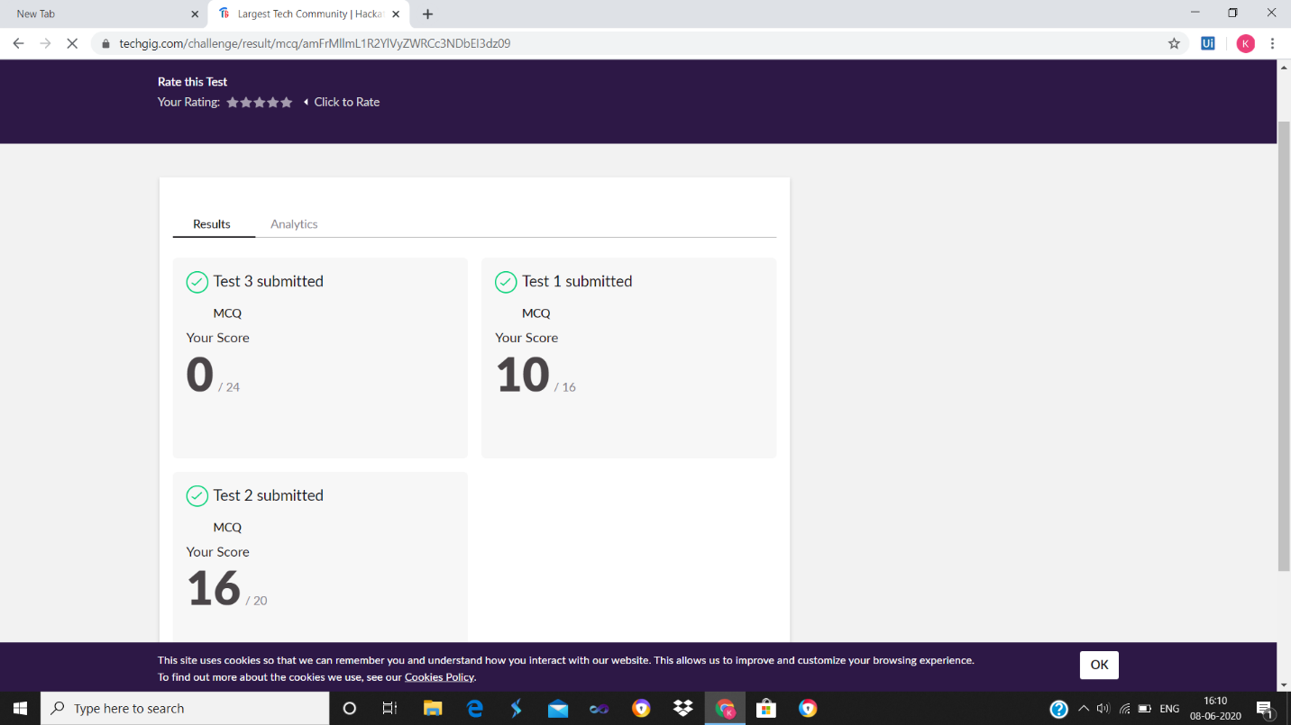

**Certification Course Details:**

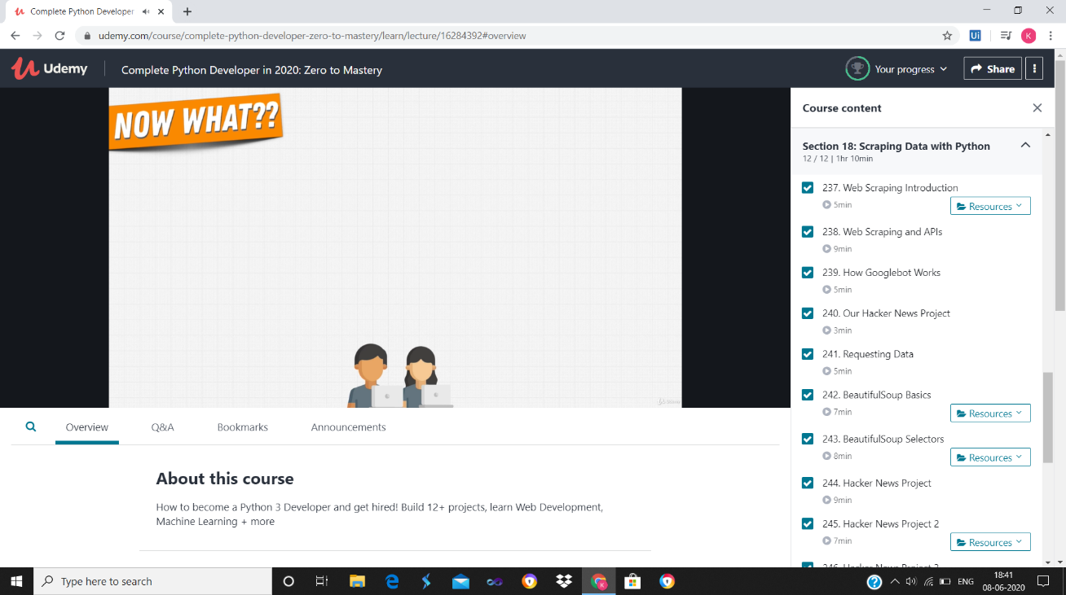

**Coding Challenges Details:**

Refer the github link for detail information :<https://github.com/kanakabs/Daily-Status/tree/master/08-06-20/online%20coding>

Solved all the problems and the solutions are uploaded in github account.

The same report is also available in github: <https://github.com/kanakabs/Daily-Status/tree/master/08-06-20>